JSP Action Tags-

There are many JSP action tags or elements. Each JSP action tag is used to perform some specific tasks

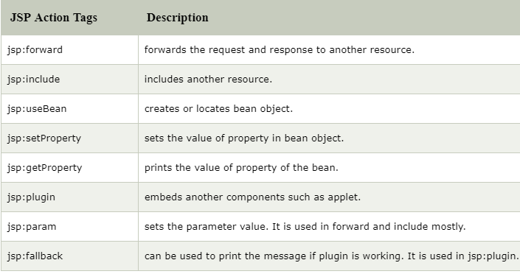`

The jsp:useBean, jsp:setProperty and jsp:getProperty tags are used for bean development. So we will see these tags in bean developement

### **jsp:forward action tag-**

The jsp:forward action tag is used to forward the request to another resource it may be jsp, html or another resource.

Syntax of jsp:forward action tag without parameter

<jsp:forward page="relativeURL | <%= expression %>" />

### **Syntax of jsp:forward action tag with parameter**

<jsp:forward page="relativeURL | <%= expression %>">

<jsp:param name="parametername" value="parametervalue | <%=expression%>" />

</jsp:forward>

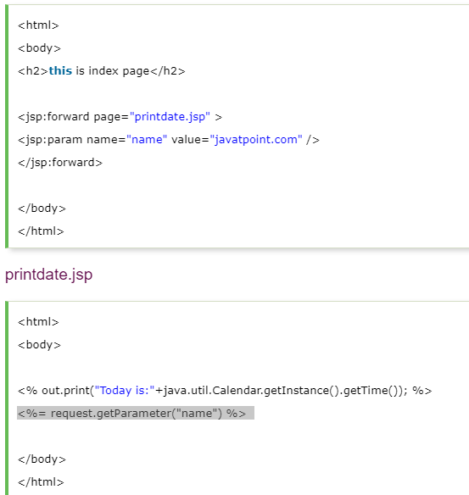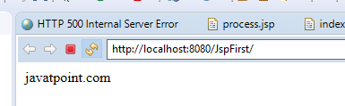

# jsp:include action tag-

# The jsp:include action tag is used to include the content of another resource it may be jsp, html or servlet.

**Code reusability** : We can use a page many times such as including header and footer pages in all pages. So it saves a lot of time.

The jsp include action tag includes the resource at request time so it is **better for dynamic pages** because there might be changes in future.

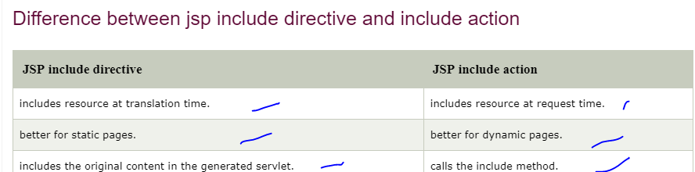

Syntax of jsp:include action tag without parameter

<jsp:include page="relativeURL | <%= expression %>" />

Syntax of jsp:include action tag with parameter

<jsp:include page="relativeURL | <%= expression %>">

<jsp:param name="parametername" value="parametervalue | <%=expression%>" />

</jsp:include>

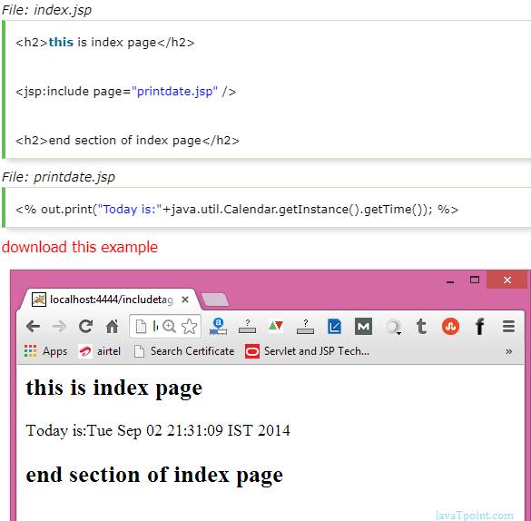

# Java Bean-

A Java Bean is a java class that should follow following conventions:

* It should have a no-arg constructor.
* It should be Serializable.
* It should provide methods to set and get the values of the properties, known as getter and setter methods.

## **Why use Java Bean?**

|  |
| --- |
| According to Java white paper, it is a reusable software component. A bean encapsulates many objects into one object, so we can access this object from multiple places. Moreover, it provides the easy maintenance. |

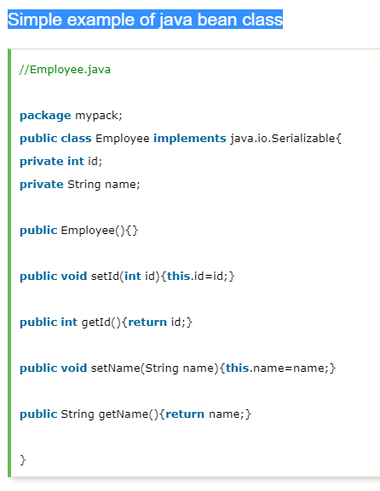

jsp:useBean action tag-

The jsp:useBean action tag is used to locate or instantiate a bean class. If bean object of the Bean class is already created, it doesn't create the bean depending on the scope. But if object of bean is not created, it instantiates the bean.

## **Syntax of jsp:useBean action tag**

<jsp:useBean id= "instanceName" scope= "page | request | session | application"

**class**= "packageName.className" type= "packageName.className"

beanName="packageName.className | <%= expression >" >

</jsp:useBean>

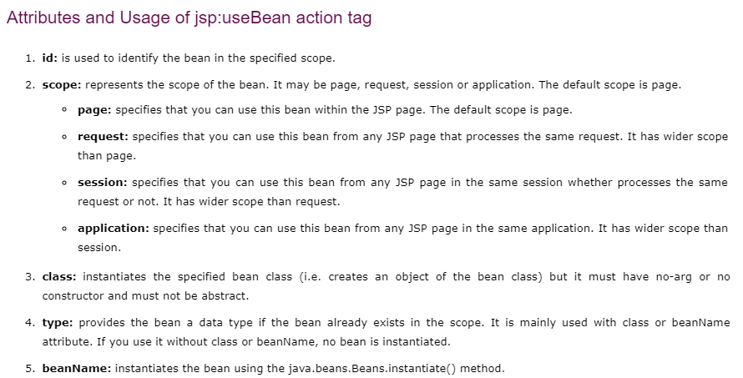

EXAMPLE->

INDEX.JSP

<jsp:useBean id=*"obj"* class=*"com.First"*/>

<%

**int** m=obj.cube(5);

out.print("cube of 5 is "+m);

%>

Class first->

**package** com;

**public** **class** First {

**public** **int** cube(**int** n)

{

**return** n+n+n;

}

}

# jsp:setProperty and jsp:getProperty action tags-

# The setProperty and getProperty action tags are used for developing web application with Java Bean. In web devlopment, bean class is mostly used because it is a reusable software component that represents data.

# The jsp:setProperty action tag sets a property value or values in a bean using the setter method.

# 

## **jsp:getProperty action tag-**

### **Syntax of jsp:getProperty action tag**

1. <jsp:getProperty name="instanceOfBean" property="propertyName" />

### **Simple example of jsp:getProperty action tag**

1. <jsp:getProperty name="obj" property="name" />

## **Example of bean development in JSP**

In this example there are 3 pages:

* index.html for input of values
* welocme.jsp file that sets the incoming values to the bean object and prints the one value
* User.java bean class that have setter and getter methods

